Possible Solutions
My system must include the following aspects: store customer details, booking information, an invoice, calculate profit and expenditure, and allow for future changes. It will achieve this through the wide range of features and formulas available in Excel.
Store Customer Details
My system will store customer details by storing them in a separate sheet to the other data. This will make the data easy to access and understand, as it is separate from other parts. It will include all the necessary information about the customer, including their full name, address, mobile and landline number, the type of ticket they ordered (and the quantity), and a unique customer reference number. This reference number will allow the customer information to go to all the other pages of the system, ensuring that Andrew will only have to enter data once, saving vast amounts of time. This is far more effective than simply writing this information down, as not only can pieces of paper not be recovered, they can also not interact with other sheets. Transferring customer details will be made easy through the use of the V/HLOOKUP function, used in conjunction with the customer reference code. Drop down boxes will be implemented to ensure that Andrew has to remember hardly anything, as well as to increase usability.
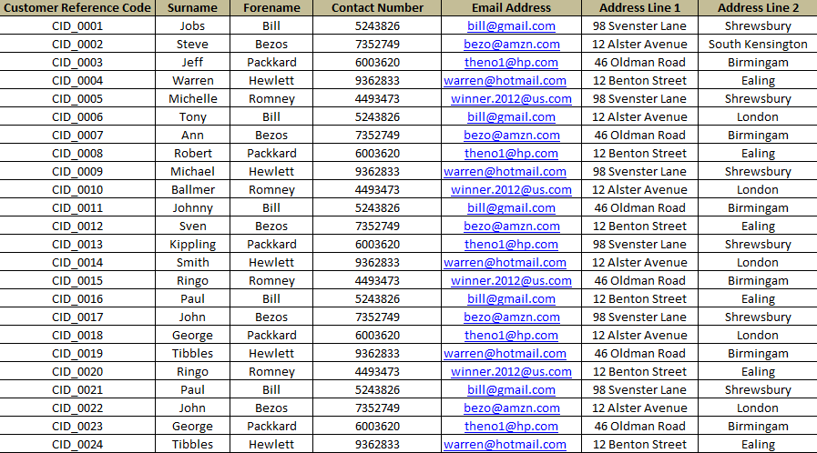
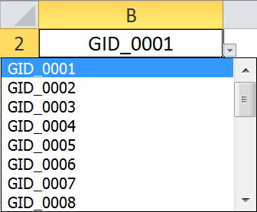
Booking Information
The system will incorporate a bookings page which will accumulate all of the customer data, as well as extra data related to the bookings, such as the type of room they have booked. This page will also be user friendly, due to the clear separation of the categories. This is important, because Andrew is not used to working with large computer systems. It will also make use of drop down menus, allowing Andrew to easily find a particular customer or room information. These tabs will be created with the ‘filter’ option in Excel, to ensure that Andrew can use them to a reasonable degree of competence, as these are very simple to use. The system will also link in with the customer details, through the same customer reference code, making the bookings page a sort of one-stop shop for all information about an order. This also increases usability compared to writing things down, as everything is in one convenient place, instead of scattered around, all over the place.
Invoices
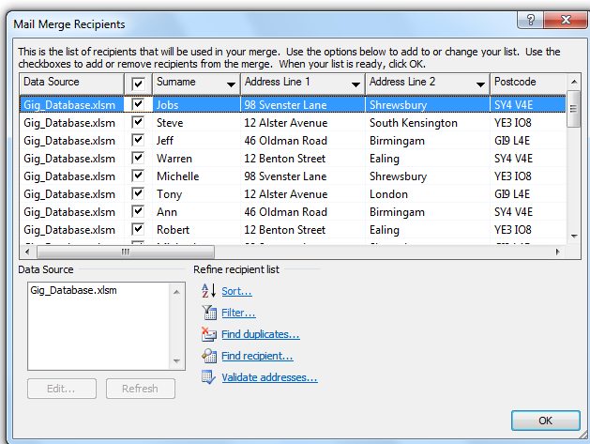
I will allow Andrew to create professional looking invoices quickly and easily through the mail merge function in Word. As he is looking to use an up to date system, one can assume that he is using at least Office 2003, and so will be able to make full use of the function. He should find it very easy to use, as there is a step by step wizard included which will guide him through it. It is also very quick, far faster than his old method of using pen and paper. Andrew can select the details he wants to input so that he can easily and effectively find out the data in his system. The use of mail merge will almost completely automate his invoice system, as he can simply import data, and create a copy of a letter for every single customer. Though the brief does not specifically mention this, based on his data storage system, we can assume that he is manually writing every single invoice, something which must no doubt cost him an awful lot of money. Using mail merge will save him both a lot of time and money, giving him more to spend on perfecting the customer experience and advertising. The printed, uniform invoices will also make him look far more professional, improving the amount of customers he gets.
Predicting Future Profits
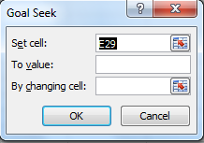
The system will make use of goal seek to enable Andrew to estimate what to set the prices at. Though not the most simple spread sheet function, it is relatively simple enough that Andrew should be able to use it. It will be of great help to Andrew, as it will help ensure that he will not lose customers due to high rates. A spreadsheet will also help him produce a cash flow forecast, a document that will allow him to forecast his profit and loss by entering his bank balance, amongst other data. By using the calculation formulas in Excel, he will be able to quickly and efficiently work out how much stock he needs to order, amongst other useful calculations. This will allow him to run his business much more effectively, because he will always know just how much he has to spend, and can budget to suit this. Goal seek will allow him to calculate the prices he should set, depending on how much profit he wants to receive. This will work in tandem with the cash flow forecast, as he will have an all-inclusive way of viewing and working out the financial side of things. (=E6:E12/C3*A5)
Allow for future changes
Due to the use of H/VLOOKUP formulas, any changes to customer details can be easily changed by simply adding customer details to one page, and all of the details will carry over to the other pages. This data can be changed very easily, because it need only be changed in one sheet, and the data will move to all the other pages. Due to the nature of Excel, it will be easy to expand the system by simply making a new sheet, and adding in the new features. This means that if Andrew ever has need of a new feature, it can be added very simply without the need for the whole thing having to be redone. With the HLOOKUP and VLOOKUP formulas, these new features can instantly integrate with the original spreadsheet, increasing the user experience.
Conclusion
Andrew has stated that he has some experience with ICT, and from that one can safely assume that he has used Excel. Though the system could be created in Access, this may make the system harder to use, as his experience with the software may be somewhat lacking compared to Excel. Excel allows for extensive use of formulas, something which is vital for the information to carry over with little fuss. It also allows for a rather nice interface to be created, something which could drastically increase the usability of the system. The “sheets” concept is also one that is easy to grasp; the separate parts of the system can be distributed across the system easily. Using Excel will also allow him to work out just how much he needs to make through the use of the Goal Seek function, giving him a unique cash flow forecast, allowing him to know how much he has to spend each month, reducing his chances of being left without any money.

